**Project Initiation Document**

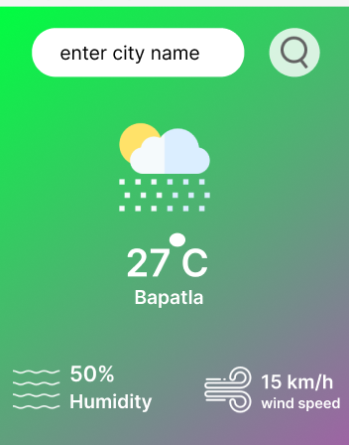

**Weather prediction based on city name**

|  |  |
| --- | --- |
| Project Number |  |
| Project Name | Weather prediction based on city name |
| Approved Date |  |
| Author |  |
| version |  |
| Strategic Goal ID |  |
| Business Plan ID |  |

* **Contents:**

**Introduction**

* Project Definition
* Project objectives
* Project scope
* Project Deliverable’s
* Project constraints

**Conclusion**

**Introduction**

* The Project Initiation Documentation (PID) is used to define the project, in order to form the basis for its management and an assessment of its overall success.
* The Project Initiation Documentation gives the direction and scope of the project and forms the ‘contract’ between the Project Manager and the Project Board.

**Project Definition**

* The goal of this project is to develop a weather prediction system that can provide accurate weather information for a given city based on its name.

**Project Objectives**

1. Develop a user-friendly interface
2. Data collection and integration
3. Real-time updates

**Project Scope**

1. city name-based Temperature Retrieval

2. Integration with Weather APIs or Data Sources

3. Location Mapping

4. User Interface Development

Top of Form

**Project Delivarables**

1. User Interface/Application
2. Documentation
3. Testing and Quality Assurance
4. Deployment Guidelines

**Project Constraints**

1. Data Availability
2. Geographical Coverage
3. Response Time
4. Scalability

**Conclusion:**

The Weather Prediction by City Name project aims to provide users with accurate weather forecasts based on their desired location. By leveraging machine learning techniques and real-time data integration, the system will empower users to make informed decisions and plan their activities accordingly.